Possible Support Plan for Student P

May 2026
Elementary School, Ontario
Student: P. (Kindergarten)
Observer: Anna Onuchina, EA Student

Goal
To support Student P in participating in classroom activities, following classroom routines, completing transitions, developing self-regulation skills, and engaging positively with peers and adults.
Strategies
• Student P may benefit from regular check-ins and supportive interactions to help build positive relationships with adults.
• Clear and consistent expectations before transitions and activities may help Student P understand what is expected.
• Visual supports such as a visual schedule, First–Then board, and transition countdown could be used to support understanding of daily routines.
• Reviewing the visual schedule at the beginning of the day and before transitions may help Student P anticipate upcoming activities.
• Showing what is happening now and what is coming next may support successful transitions.
• Short and clear First–Then statements might help increase participation in non-preferred activities.

Examples of visual supports may include:
1. Visual Schedule
Review the visual schedule at the beginning of the day, for example:

School Yard → Transition to Class → Carpet Time → Snack → Class Activity → Transition Outside → Play Time → Transition to Class → Lunch Time → Carpet Time → Play Time → Transition Outside → Time to Go Home.
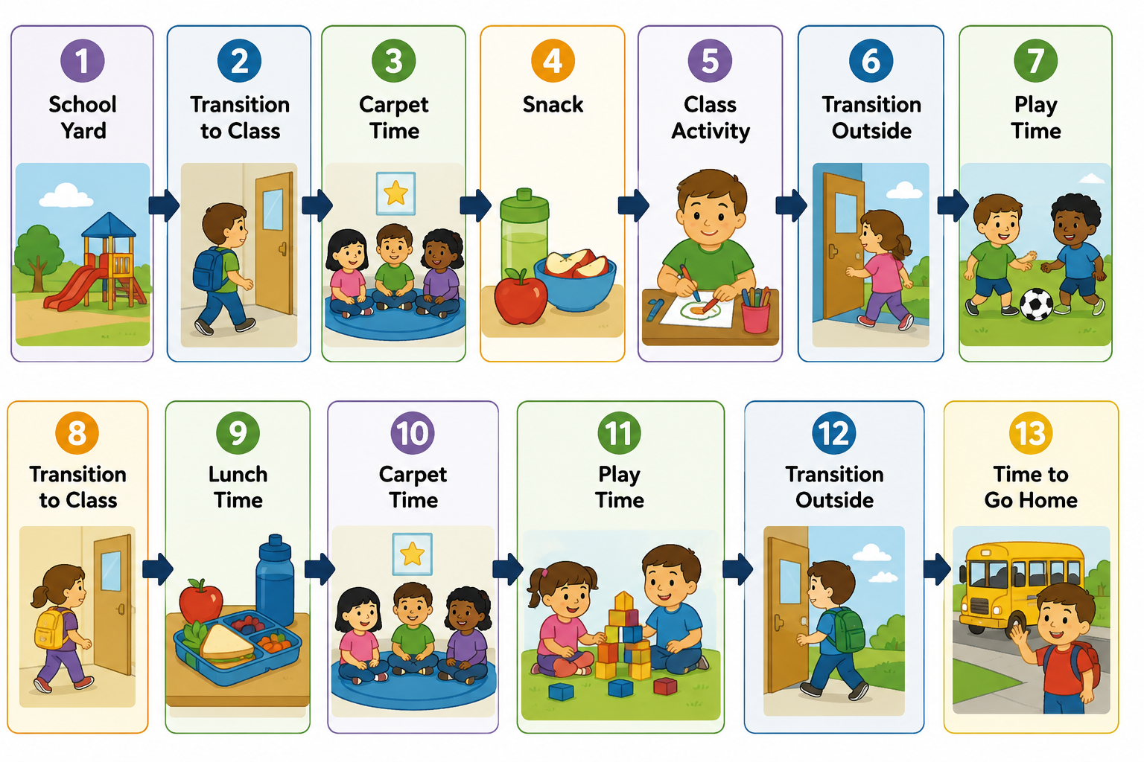
• Refer to the schedule before transitions.
• Show Student P. what is happening now and what is coming next.
2. First–Then Support. Examples:
• First carpet time, then play.
• First clean up, then play.
• First sit on the carpet, then play.
• First line up, then play outside.
• First listen to the teacher, then play.
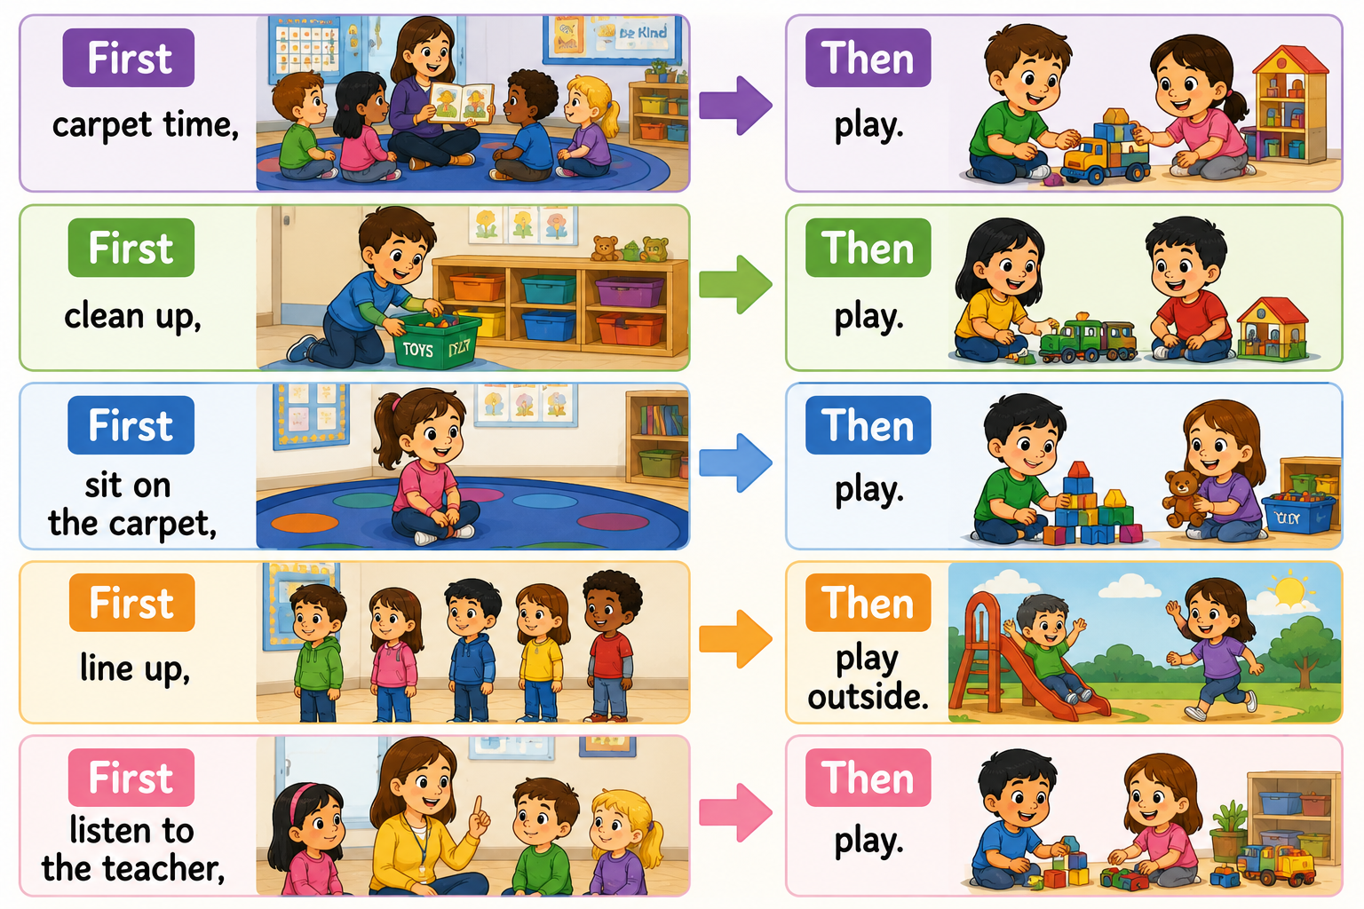
Other Possible Support Strategies:
Offering limited choices, when appropriate, may help increase cooperation and independence. Examples:
- "Would you like to walk with me or with the class?"
- "Would you like to sit on the carpet or in the calm corner?"

Calm, supportive language may be helpful during periods of frustration or refusal.
• Access to a designated regulation space or calm corner could be offered when Student P. appears overwhelmed.
• Breaking tasks into smaller, manageable steps may support task completion.
• Providing additional processing time before repeating directions may be beneficial.
• Immediate and specific praise may help reinforce positive behaviours and participation.
Examples:
- "Great job sitting on the carpet."
- "Nice walking with the class."
- "Thank you for following directions."

Sensory Regulation
Movement opportunities and sensory breaks throughout the day may support regulation and engagement.
• Classroom helper opportunities that involve movement and responsibility could be offered when appropriate.
• Access to sensory supports during activities, waiting periods, and transitions may be beneficial. Examples:
- Sensory fidgets.
- Carrying materials.
- Delivering items.
- Helping with classroom set-up and clean-up.
- Approved oral sensory supports, if available and approved by the school team and family.

Helper roles may be used before challenging transitions or group activities.
Examples:
- Materials helper.
- Classroom helper.
- Teacher’s helper.
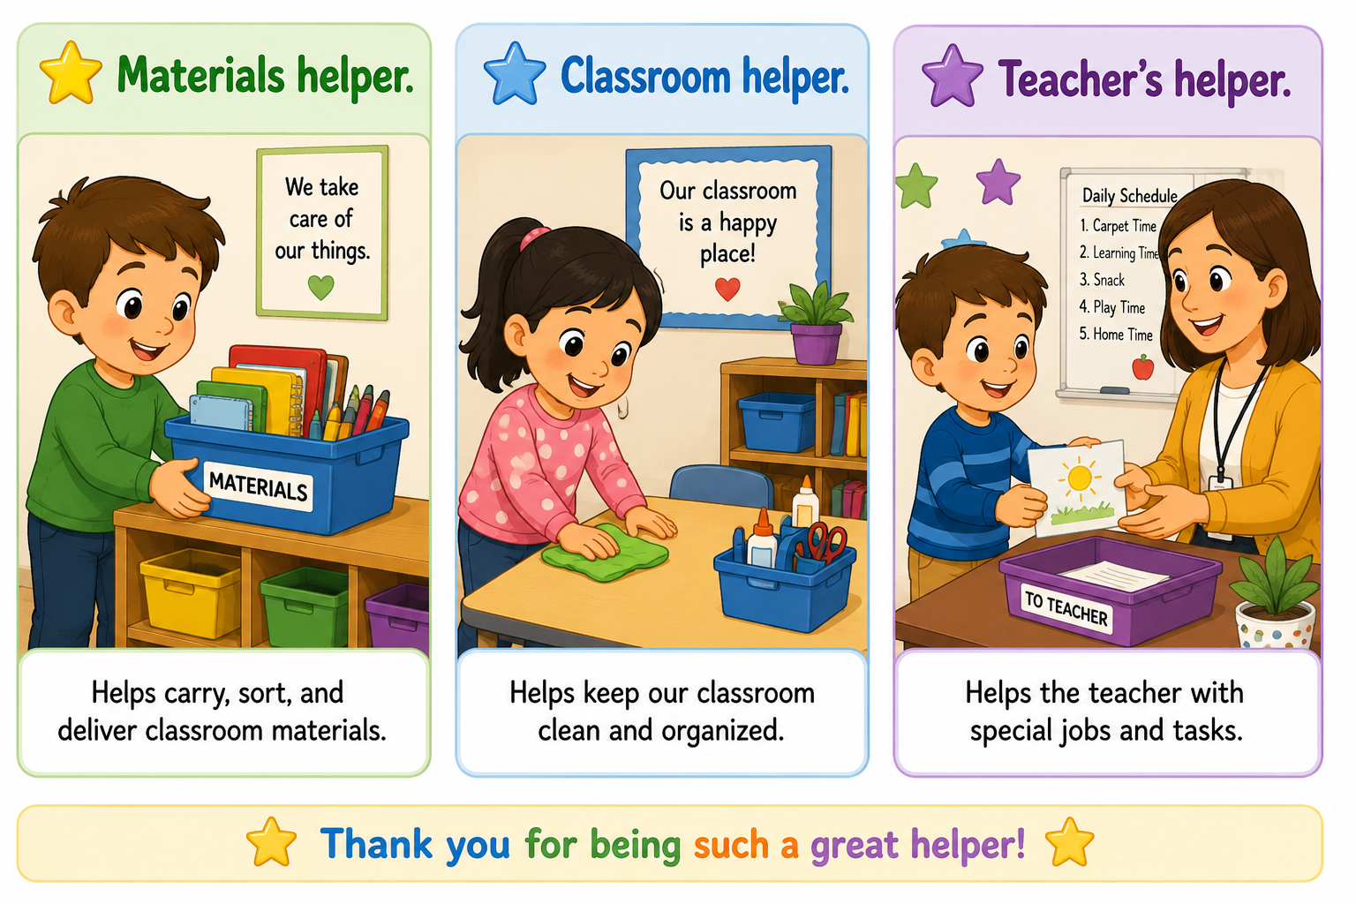

A simple star reward system could be considered to encourage participation and positive behaviour.
Student may earn a star during the day for:
⭐ Sitting nicely on the carpet.
⭐ Walking with the class in line.
⭐ Being a helper.
⭐ Following teacher directions.
⭐ Playing nicely with peers.
Goal:
5 stars = preferred classroom activity or another teacher-selected reward.
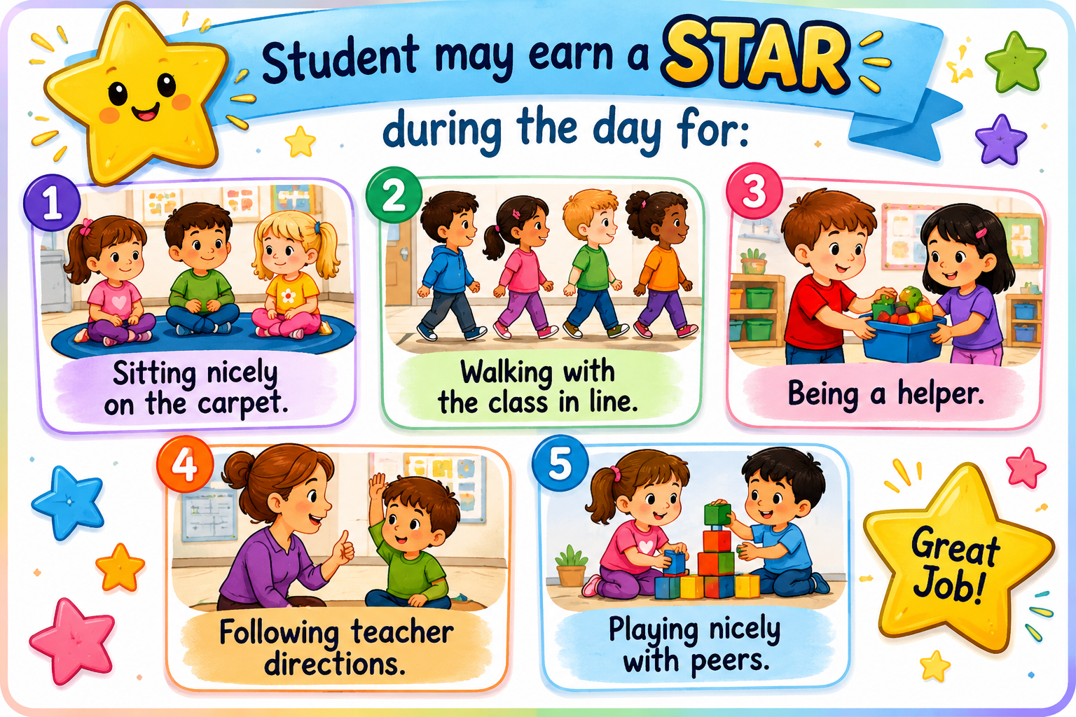

Collaboration between the family and the school team may help identify effective ways to support Student P and promote a consistent approach across home and school settings.

Monitoring
• The frequency of transition difficulties and successful transitions could be monitored.
• Participation during carpet time and group activities may be documented.
• Peer interactions and any incidents of conflict could be observed and recorded.
• Strategies used and Student P’s responses may be documented to identify successful supports.
• Progress may be reviewed periodically and supports adjusted as needed.

Expected Outcome
With consistent visual supports, positive reinforcement, sensory supports, structured routines, and adult guidance, Student P may demonstrate increased participation in classroom activities, improved transition skills, greater independence, and stronger self-regulation skills.

