Possible De-Escalation and Collaboration Support Plan for Student F
Student Profile / Observations
Student F appears sensitive to repeated adult prompting and may become emotionally overwhelmed during frustration or perceived pressure.
Escalation may occur when:
- multiple demands are repeated;
- the student feels a loss of control;
- adults continue talking during dysregulation;
- tasks are introduced too quickly after refusal.
Possible early signs of escalation:
- refusal;
- lowered eye contact;
- angry tone of voice;
- withdrawal;
- frustration;
- crying or shutting down.
.

Goal of the Plan
The purpose of the plan is to:
- reduce escalation;
- increase cooperation with staff;
- improve emotional regulation;
- support respectful communication;
- help the student return to tasks more successfully.

Preventative / Proactive Strategies

- Reduce Verbal Overload
Instead of repeating instructions multiple times:
• give one short direction;
• wait 10–15 seconds before speaking again;
• avoid long explanations during frustration.
Examples:
• “First clean, then break.”
• “You can start when ready.”
- Use Calm Tone + Neutral Body Language
During escalation:
• keep voice low and calm;
• stand beside the student instead of directly in front;
• avoid fast movements or pointing;
• avoid arguing or emotional reactions.
Purpose:
Reduce feeling of pressure or confrontation.
- Give Controlled Choices
Provide only 2 clear options.
Examples:
• “Table first or lunchbox first?”
• “Do you want help or independent?”
• “Do you want one minute first?” (Give the student short processing time)
Purpose:
Increase the student’s sense of control without removing expectations.
- Use Processing Time
After giving direction:
- pause;
- allow the student time to think and regulate;
- avoid immediately repeating instructions.
If student refuses:
• reduce talking;
• step back briefly if safe;
• return calmly after short pause.

- Pre-Correction Before Difficult Tasks
Before transitions or non-preferred tasks:
• remind student calmly what is expected;
• explain steps briefly;
• reduce surprises.
Example:
• “After writing, clean the table.”
Purpose:
Reduce anxiety and emotional overload during transitions.

- Positive Reinforcement / Reward Chart

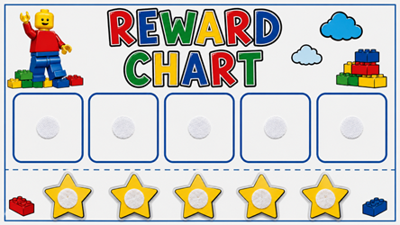

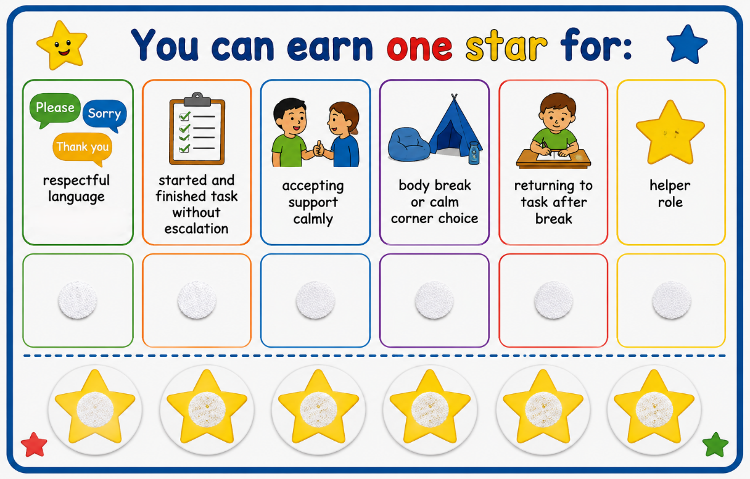

Student earns one star for:
• respectful language (“Sorry”, “Please”, “Thank you” etc.)
• started and finished task without escalation
• accepting support calmly
• choosing a body break or calm corner
•returning to task after break
• helper role

Important:
Reward is connected to effort, regulation, and cooperation — not perfection.

De-Escalation During Escalation
If escalation begins, the EA may:
- maintain calm communication;
- avoid repeated correction;
- provide emotional space if safe;
- keep directions short.
Examples:
• “Take your time.”
• “I’ll help when you are ready.”
• “We can try again when you are ready.”

Return to Task Strategy
After student becomes calmer:
• avoid discussing behaviour immediately
• restart with one small step
• praise cooperation quickly
Examples:
• “Thank you for starting.”
• “Good job trying.”
Purpose:
Help student re-enter activity successfully without restarting conflict.

Observation / ABC Tracking
The EA may observe:
- what happened before escalation (e.g., transitions, difficult tasks, correction from an adult, denied preferred activity);
- how many prompts were given;
- tone of adult interaction;
- successful calming strategies.
Purpose:
Identify triggers and behavioural patterns in order to improve future support strategies, reduce escalation, and help the student regulate more successfully during classroom activities and transitions.
Examples of identifying triggers:
- observing if escalation begins after repeated prompts;
- noticing whether frustration increases during transitions or clean-up;
- observing body language before escalation (e.g., lowered eye contact, withdrawal, angry tone, refusal).
Examples of regulation support:
- giving processing time before repeating instructions;
- offering calm choices instead of repeated demands;
- allowing a short movement or sensory break before returning to task;
- restarting activities with one small achievable step.
Examples of successful support strategies:
- the student begins the task after one calm reminder;
- the student asks for a break instead of yelling;
- the student accepts support after processing time;
- the student returns to the activity after a short pause without further escalation.

Long-Term Goal
Long-term goals for Student F:
- improve emotional regulation (e.g., taking a short break before yelling, using a calmer voice during frustration, accepting support without escalation);
- communicate frustration more appropriately (e.g., saying “I need a minute,” “I need a break,” “I need space,” “I need help”, “I’m upset”);
- use coping strategies before escalation (e.g., deep breathing, short movement break, asking for processing time, using calming activities);
- participate more successfully during classroom routines and transitions (e.g., beginning clean-up after one reminder, transitioning between activities with reduced refusal, following classroom routines with fewer prompts).
